Assignment 1

**create 'student_db' database:**

**CREATE DATABASE student_db;**

**USE database:**

**USE student_db;**

**create following tables in database with proper data types of student: id (PK), name, address, phone, email, age, schoolId (FK) school: id (PK), name, address, principal, phone**

create table school (

    id int PRIMARY KEY identity (1,1),

    name varchar(20),

    address varchar(50),

    principal varchar (20),

    phone bigint

);

 create table student(

    id int PRIMARY KEY identity (1,1),

    name VARCHAR(30),

    address VARCHAR(30),

    phone bigint,

    email VARCHAR(30),

    age int,

    schoolId int,

    FOREIGN key(schoolId) REFERENCES student(id)

 );

insert into school(

    name,

    address,

    principal,

    phone

)

values (

    'jaihind school',

    'new road, Dhule',

    'Ashok Sonawane',

    4343241623

),

 (

    'devi school',

    'old road, Dhule',

    'dilip joshi',

    9908889683

),

(

   'army school',

    'sakri road, Dhule',

    'sunita wagh',

    1877929522

),

(

    'modern school',

    'karve road, Dhule',

    'Anita jadhav',

    8395044798

),

(

    'jaihind school',

    'mhatre road, Dhule',

    'suresh sharma',

    1305415452

),

(

    'jaihind school',

    'garden road, Dhule',

    'kartiki aagale',

    6927982022

);

  insert into student(

    id,

    name,

    address,

    phone,

    email,

    age,

    schoolId

)

values (

    1,

    'Ajinkya Sonawane',

    ' akshay colony, Dhule',

    9455249295,

    'ajinkya@gmail.com',

    15,

    1

),

 (

    2,

    'mayuri kadam',

    ' ganesh colony, Dhule',

    9349695293,

    'mayuri@gmail.com',

    16,

    2

),

(

    3,

    'surabhi sharma',

    'raviraj colony, Dhule',

    4324860347,

    'surubhi@gmail.com',

    13,

    3

),

(

    4,

    'neha mane',

    ' sai colony, Dhule',

   5724291578,

    'neha@gmail.com',

    14,

    4

),

(

    5,

    'rahul kambale',

    'martand colony, Dhule',

    8315753177,

    'rahul@gmail.com',

    15,

    5

),

(   6,

    'rohit gayakwad',

    'gayatri colony, Dhule',

    9814845997,

    'rohit@gmail.com',

    14,

    6

);

**Select * from school;**

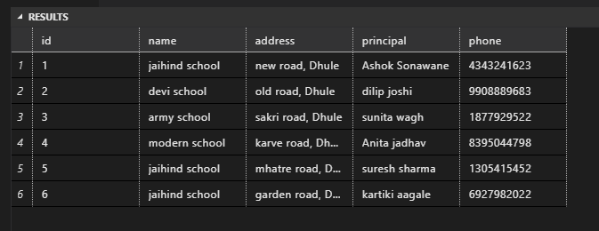

**Select * from student;**

